Interfacing ADC with 8051 Microcontroller


LAB # 11

Spring 2024
CSE-307L Microprocessor Based System Design Lab

Submitted by: Ali Asghar
Registration No.: 21PWCSE2059
Class Section: C

“On my honor, as student of University of Engineering and Technology, I have neither given nor received unauthorized assistance on this academic work.”

Submitted to:
Dr. Asif Ali Khan

Date:
23rd May 2024

Department of Computer Systems Engineering
University of Engineering and Technology, Peshawar

Task 1:
From temperature sensor (LM35) read temperature and convert it into Digital value by using ADC0804 and display the value on the LCD. In LCD at first line write your registration Number and on the second line display the value of the temperature sensor attached with ADC0804.

Code:
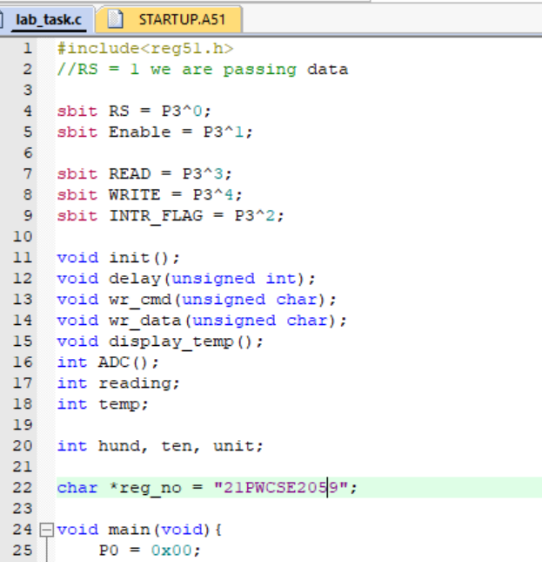
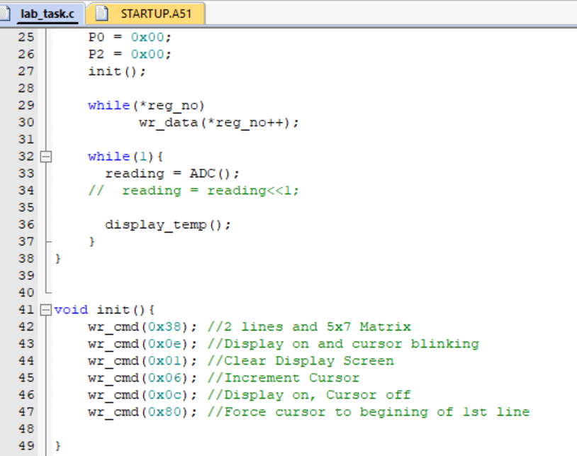
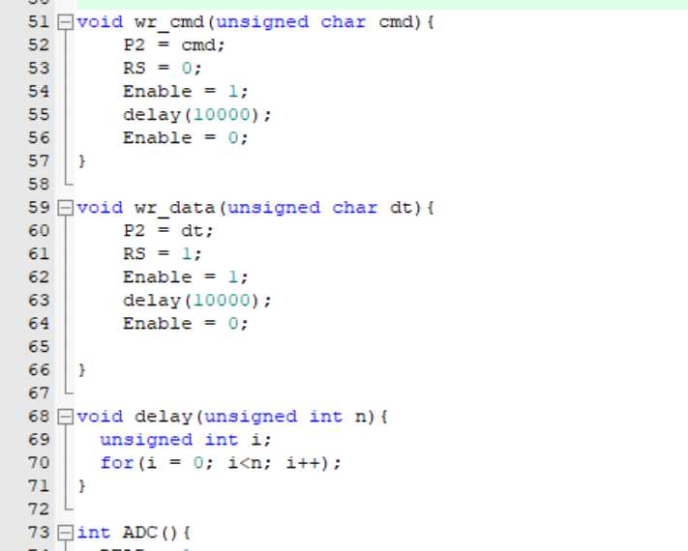

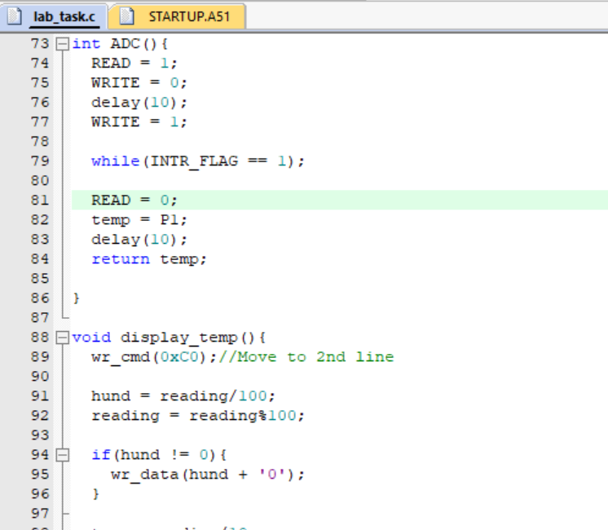
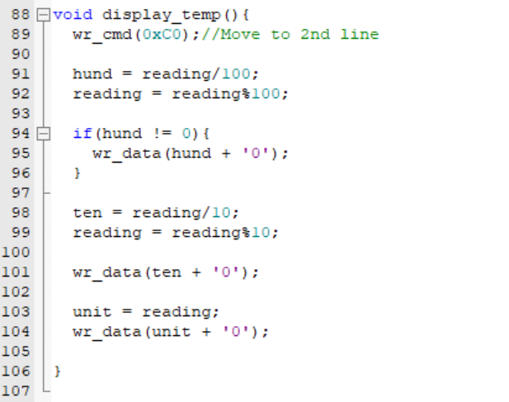

Proteus Simulation:
